FIGMA
NAME: VIDULA R COURSE CODE: CSA1013
REG NO : 192511270 COURSE NAME: SOFTWARE ENGINEERING

EX 01 - BUS TICKET BOOKING SYSTEM USING FIGMA

AIM
To design and develop a simple FOUR-screen Bus Ticket Booking System prototype using Figma, including user login, bus search and seat selection, and booking confirmation.

WORKFLOW

Login page
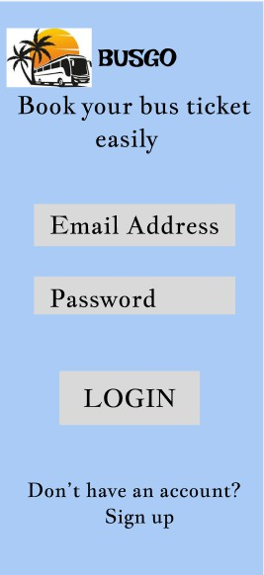

Search buses
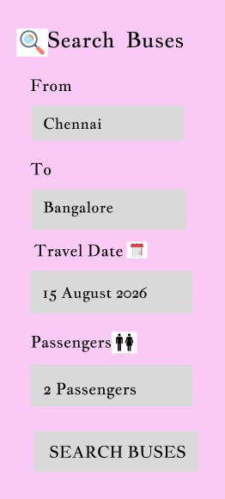

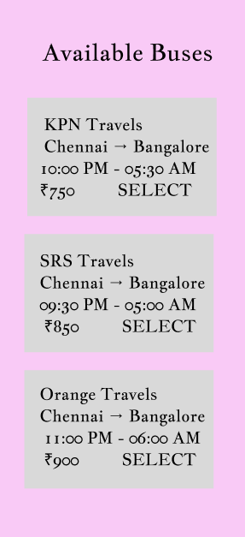
Available Buses

- Booking confirmation
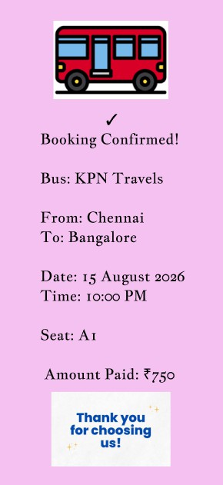

RESULT
A four screen Bus Ticket Booking System prototype was successfully designed using Figma, including Login, Bus Search & Seat Selection, and Booking Confirmation screens with a simple interactive workflow.

EX 02 - E-COMMERCE MOBILE APPLICATION USING FIGMA

AIM
To design a simple Bus Ticket Booking System prototype using Figma that enables users to search for buses, select a bus and seat, and confirm their booking.

WORKFLOW

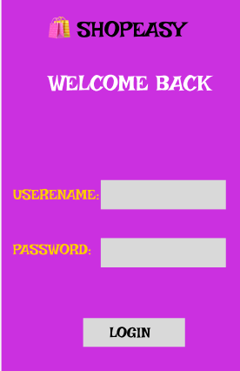
Login Page

- Homme Page
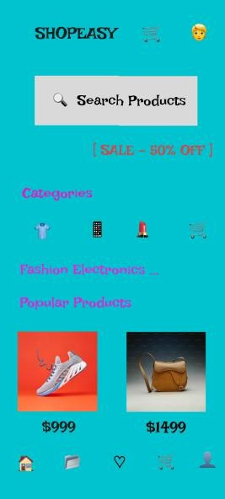

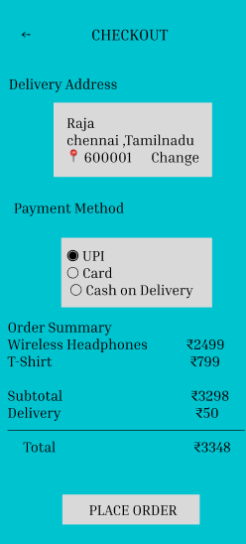
Checkout Page


- Order Confirmation

RESULT
A simple 3-screen interactive Bus Ticket Booking System prototype was successfully designed using Figma, demonstrating the basic bus search, seat selection, and booking confirmation process.

